Ex 5a Simulate the lifecycle stages for UI design using the RAD model and develop a small interactive interface using Axure RP
Aim:
To design and develop an interactive Fitness Tracker User Interface using Axure RP by simulating the lifecycle stages of the RAD (Rapid Application Development) model.

Procedure:
Phase 1: Requirements Planning
- Identify Features:
  - User login system
  - Dashboard to display fitness data
  - Activity selection (Walking, Running, Cycling)
  - Progress tracking (steps, calories)
  - User profile management
- Define User Actions:
  - Login to the system
  - View daily fitness stats
  - Select and start workout
  - Track progress
  - View and edit profile
- Prepare Requirement Document:
  - Listed all screens and functionalities
  - Defined user flow from login to profile

Phase 2: User Design
- Open Axure RP:
  - Launch Axure RP software
  - Create a new project named “Fitness Tracker App”

- Create Pages (Screens):
  - Login Page
  - Dashboard Page
  - Activity Page
  - Progress Page
  - Profile Page

- Design Wireframes:
- Login Page:
  - Added text fields for email and password
  - Added login button
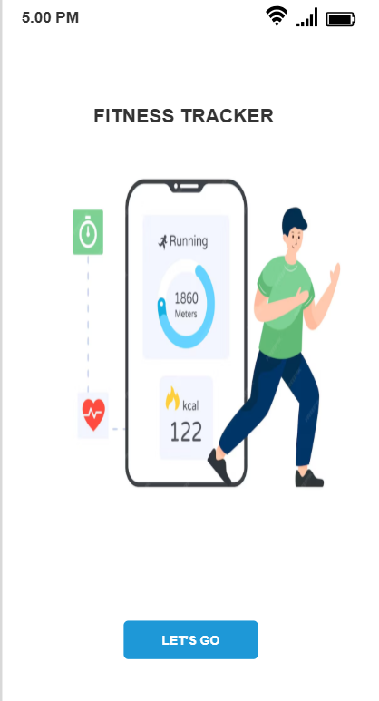
- Dashboard:
  - Displayed steps, calories, and water intake
  - Added progress bars
  - Included “Start Workout” button
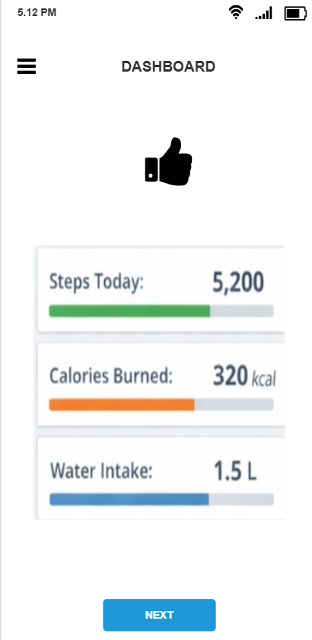
- Activity Page:
  - Added options: Walking, Running, Cycling
  - Added Start button
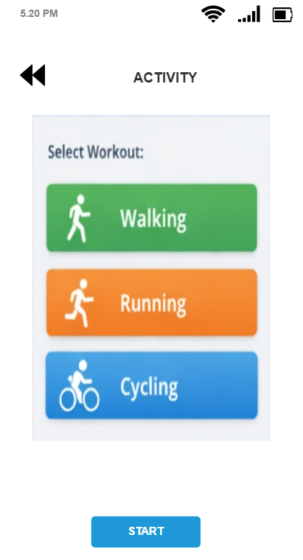
- Progress Page:
  - Displayed weekly steps (bar chart)
  - Displayed calories trend (line chart)
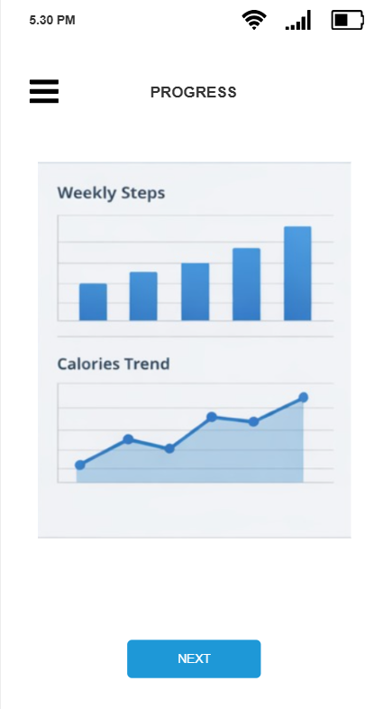
- Profile Page:
  - Added user details
  - Included Edit and Logout buttons
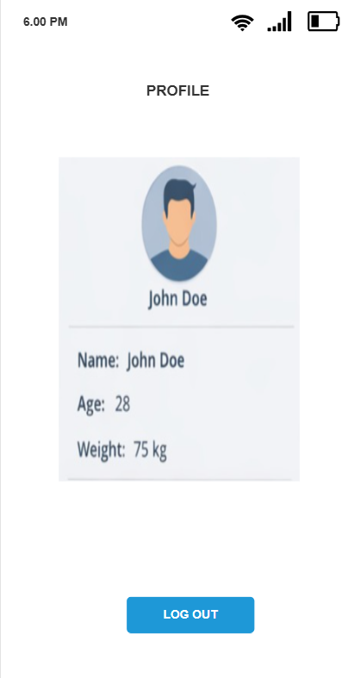

- Add Interactions:
  - Login button → Navigate to Dashboard
  - Start Workout → Navigate to Activity Page
  - Navigation buttons → Switch between screens
  - Logout → Return to Login Page
- Create Master Components:
  - Designed a bottom navigation bar
  - Used it across all pages

- Add Annotations:
  - Described purpose of each UI element
  - Explained navigation and user actions

Phase 3: Construction
- Develop Interactive Prototype:
  - Added clickable buttons and navigation links
  - Used dynamic panels for interaction (if any)
- Preview Prototype:
  - Clicked Preview option in Axure
  - Tested navigation between pages
- Iterate Design:
  - Improved layout and interactions
  - Ensured smooth user experience

Phase 4: Cutover
- Finalize Design:
  - Checked all screens and interactions
- Export Prototype:
  - Published project to Axure Cloud / HTML
- User Guidance:
  - Explained app usage
  - Demonstrated navigation flow

Result:
Successfully designed and developed an interactive Fitness Tracker UI prototype using Axure RP by following the RAD model stages.

Conclusion:
The RAD model enabled rapid development and iterative improvement of the UI. Axure RP helped in creating an effective and interactive prototype with multiple screens and smooth navigation.

Reference:
Axure Project Link:
https://muld5z.axshare.com/?g=4

